SURGICAL ONCOLOGY COMMITTEE MEMBERSHIP APPLICATION
The Committee will consist of approximately 30 members, and the members will be appointed by the NRG Oncology Group Chairs upon recommendation of the Surgical Oncology co-chairs. To be considered for the Committee, investigators must submit an application form and packet (please see below). The applications will be reviewed by the Surgical Oncology co-chairs, who will make recommendations to the NRG Group Chairs based on the applicant’s prior track record of patient accrual to NRG Oncology trials, clinical trial experience, clinical or research expertise, disease site specialty and involvement in current NRG Oncology trials. Applications and materials must be submitted by March 2, 2018.

Committee members are expected to attend the NRG Oncology semiannual meetings and participate in between meeting conferences calls as needed. The will be no funding support from NRG Oncology to attend the meetings.

Applicant must submit:
- The completed application form
- A brief NIH-type biosketch that identifies only key information OR an abridged (limit 4 pages) CV
- A brief less than one (1) page cover letter stating the reasons why the applicant wishes to join the committee, what contributions he/she expects to make to the group, and outlining relevant past contributions and accomplishments. The new NIH biosketch format may be used in lieu of the cover letter (http://grants.nih.gov/grants/funding/424/index.htm#format).

Application packages should be sent electronically to:
Committee-Nominations@nrgoncology.org
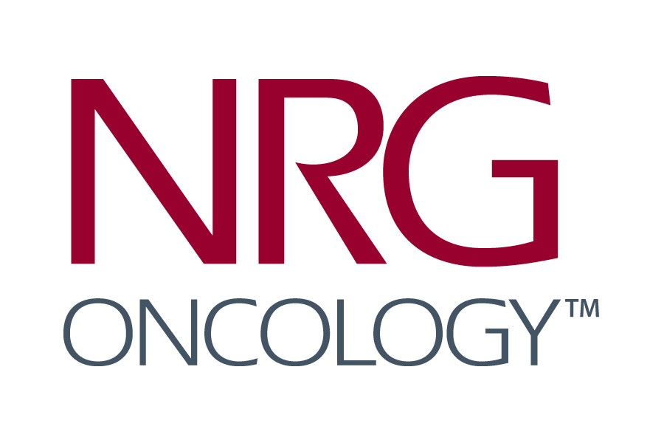
SURGICAL ONCOLOGY COMMITTEE
APPLICATION FORM
Name
Participating Institution
Address

City, State, Zip
Country
Phone
Email

NRG Oncology Membership Status:
LAPS NCORP Main Member Affiliate
Specialty
Disease Site, Specify:
Institutional accrual to NRG Oncology trials in the past 5 years (including affiliates)
Number of patients
Area(s) of Clinical/Research Expertise:
Involvement with Current NRG Oncology Trials
Are you currently the PI or a Co-chair on a current NRG Oncology trial?
Yes Which Trial No
Recent Past Surgical Oncology Committee Meeting Attendance: Yes No

Submit application package including the biosketch and cover letter electronically to:
Committee-Nominations@nrgoncology.org

